##### PROGRAM:

<?php

$host=

$password=””;

$conn=mysqli_connect($host,$user,$password);if(!$conn)

{

Die(‘couldnotconnect:’,mysql_connect_error());

}

echo”connectsuccessfully(‘br/>’)”;

$sql=’Createdatabasemydb’;

$sql="createtableemp(id int,namevarchar(10)NOTNULL,empsalaryINTNOTNULL,primarykey(id))";

$sql=”insertintoemp(id,name,empsalary)values(312,RANA,200000)”;

$sql=”deletefrom empwhere id=1”;

$sql=”updateempset empsalary=9000000whereid=312”;if(mysqli_query($conn,$sql))

{echo”operationsfailedfailed”,mysqli_error($conn);

}

mysqli_close($conn);

**?>**

##### OUTPUT:

Aftercreationofdatabaseandemptable



Afterinsertion:

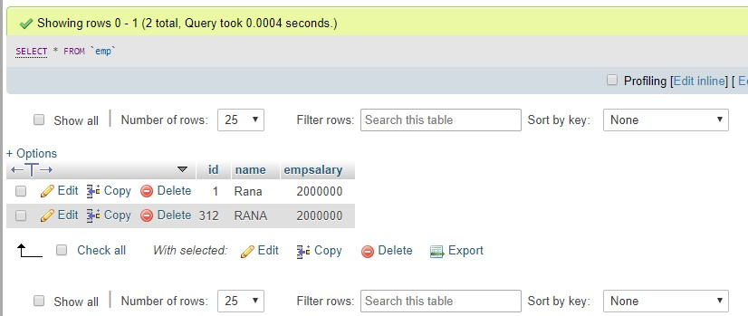

Afterdeletion:

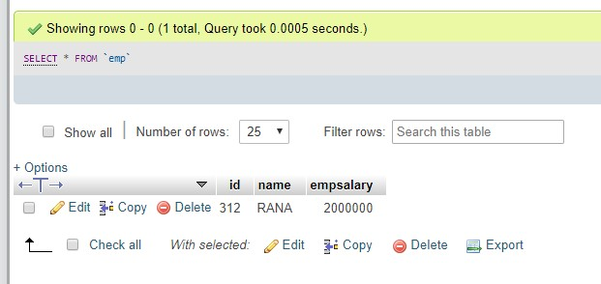

Afterupdation:

